YCRC Return To Play Protocol

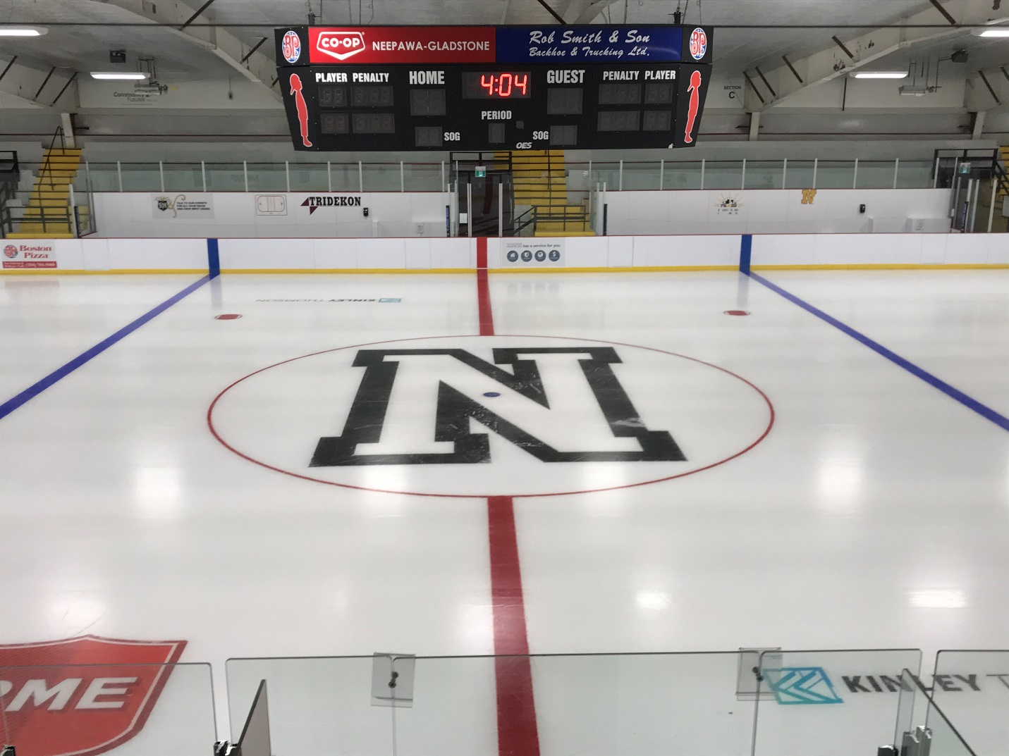

The Yellowhead Community Rec Centre is committed to ensuring the health and safety of our user groups and staff. The facility will only be accessible to participants of pre-arranged bookings and appointments. Spectators will be limited. This document will remain fluid and may change at any time in order to follow changes to government standards and guidelines. The use of face masks is mandatory within the facility at all times.

LEGAL DISCLAIMER
The information contained in this document is not intended as a substitute for professional medical prognosis, recommendations, or treatment. The Yellowhead Community Rec Centre makes no representation and assumes no responsibility regarding the information concerning COVID – 19 due to the constant updates, and any information on COVID – 19 should be obtained from the Provincial Health Authority.

HEALTH SCREENING
- Health and safety of guests and employees is our number one priority. All staff, instructors, spectators and users are required to complete the self-screening questionnaire prior to arrival: https://sharedhealthmb.ca/covid/screening-tool/.
- Individuals who do not pass the screening or experience symptoms associated with Covid-19, (even mild symptoms) should not participate that day. Any individual displaying symptoms associated with Covid-19 will be denied entry.
- User groups, including coaches and spectators, must adhere to any provincial travel restrictions and self-isolation protocols the Government of Manitoba may have in place at any given time.
Most common symptoms:
- fever
- dry cough
- tiredness
Less common symptoms:
- aches and pains
- sore throat
- diarrhoea
- conjunctivitis
- headache
- loss of taste or smell
- a rash on skin, or discolouration of fingers or toes
Serious symptoms:
- difficulty breathing or shortness of breath
- chest pain or pressure
- loss of speech or movement

PHYSICAL DISTANCING & HAND SANITIZER
- All employees and users must adhere to physical distancing guidelines by standing and sitting at least two metres away from other people throughout the facility, except for brief exchanges. While on the ice, users must be an extended stick length away as much as possible. Members of the same household may sit together.
- Hand sanitizer will be available throughout the facility. Dispensers will be located at entrance, dressing rooms, washrooms, as well as high-traffic areas. When entering the facility all patrons are required to utilize the hand sanitizer.

FACILITY MAINTENANCE & SANITIZATION
New protocols and procedures are in place to maintain provincial standards to prevent the spread of COVID-19. This includes, but is not limited to:
- Restricted facility access;
- Signage to remind patrons of physical distancing and hand hygiene; All who enter MUST pay attention to and follow signs and protocols.
- Providing hand sanitizer throughout the facility;
- Increased frequency of cleaning in washrooms and high traffic areas;
- Regular sanitization of dressing rooms and all benches in accordance with government standards; and
- Increased supervision.

ARRIVAL/DROP OFF
- A member of each group must be designated to greet their own members and confirm those entering the facility are part of their group and that the self-screening questionnaire has been completed by the participants. Names and contact information of participants must be kept by the renter for a minimum of 21 days for potential contact tracing purposes. This individual must be in attendance before the group enters the facility.
- All individuals are required to utilize the hand sanitizer.
- Individuals must report directly to their designated area.
- Facility entrance is limited to one household at a time. While waiting to enter the building, patrons must line up in the designated area while ensuring physical distancing.
- Entrance, exit, and directional signs will be placed on doors and floors to indicate traffic flow throughout the facility and must be adhered to at all times
- Access to the facility is limited to thirty (30) minutes before and twenty (20) minutes after the scheduled ice time. Failure to vacate the facility within the allocated time limit will result in an additional arena facility rate charge. A 15 minute arena charge will be invoice for every 5 minutes patrons exceed their time limit.
- All users are strongly encouraged to come fully dressed, minus helmets and skates.

SPECTATORS
- With the exception of guardians who are assisting children with dressing, spectators must report directly to a designated viewing area and should only leave their seats to use the washroom or arena concession. Spectators assisting children must report to designated viewing area immediately after children are dressed.
- Current regulations will allow a seating capacity of 294 spectators in the arena stands provided spectators are socially distanced properly, and 32 people in the arena lobby. When passing others in the hallways or doorways, please stay to the right (keep oncoming traffic to your left).
- Washrooms directly off the viewing area are available for spectator use. Maximum of two individuals per restroom.
- Masks must be worn by players, coaches, parents, spectators, volunteers at all times (Except during on ice activities)

GENERAL ARENA RULES
- Social distancing is required throughout the facility
- Maximum people on the ice = 40 (includes players/skaters, coaches, officials)
- Maximum people in the stands = 294
- No dryland or team warm-ups allowed inside the facility
- Each user group is asked to do their best to ensure physical distancing is adhered to on the bench.
- The number of players/participants per dressing room are as follows:
Room #1: (9)
Room #2: (9)
Room #3: (7)
Room #4: (10)
Room #5: (12)
Room #6: (12)
Referee: (6)
- Dressing rooms have numbered stalls. All individuals will be asked to proceed directly to their assigned dressing room and stall and remain socially distanced while putting equipment on. (No horseplay or entering another participant’s stall/personal space). Players should remain in their stall until it is their time to go on the ice.
- Players must be supervised in the dressing rooms at all time to ensure the rules are being followed and social distancing is maintained.
- Showers are not available for use after practices, but may be used after games. Players must still exit the facility within 20 minutes after ice time has ended.
- Teams should keep dressing rooms tidy (no tape or garbage on floor) to help maintain sanitary conditions.
- Absolutely no spitting or fighting at any time. A zero tolerance policy regarding spitting and fighting will be enforced and individuals may be asked to leave the premises and have future bookings suspended.
- The water fountain will not be available. The motion sensor bottle filling stations will be available but we would prefer users bring their own labeled, pre-filled water bottle. Sharing of water bottles is prohibited.
- As in restaurants or stores, children that are not on the ice should be seated with their parents and not be allowed to wander or run around on their own. Running/wandering children are not likely adhering to social distancing guidelines and are potentially invading the space of those who are trying to maintain their distance.
EXCEPTIONS (Sport/League Specific Return to Play (RTP) Documents)
- MJHL games/practices/events will follow the current phase of the MJHL’s RTP and restrictions/allowances described therein. Most notable change is the allowance of 35% occupancy for pre-season games and 50% occupancy for regular season games (beginning September 18, 2020). Those in charge of MJHL sanctioned events (Neepawa Natives executive, staff, and volunteers) are expected to know and follow the MJHL’s RTP and should help the facility ensure all who are associated with their events (spectators, officials, etc.), are informed of and follow the guidelines also. The MJHL RTP can be found at: http://30sobg2guf3ia3og81byuwpi-wpengine.netdna-ssl.com/wp-content/uploads/sites/2/2020/08/MJHL-Return-to-Play-Phase-ll.pdf

- Hockey Manitoba sanctioned events will follow the current phase of Hockey Manitoba’s RTP and the restrictions/allowances described therein. Those in charge of Hockey Manitoba sanctioned events (Neepawa Minor Hockey Association, it’s executives, coaches, managers, and members) are expected to know and follow Hockey Manitoba’s RTP and should help the facility ensure all who are associated with their events (spectators, officials, etc.), are informed of and follow the guidelines also. Hockey Manitoba’s RTP can be found at: http://www.hockeymanitoba.ca/return-to-play/

- Skate Manitoba sanctioned events will follow the current phase of Skate Manitoba’s RTP. Those in charge of Skate Manitoba sanctioned events (Neepawa Figure Skating Club, it’s executives, coaches, and members) are expected to know and follow Skate Manitoba’s RTP and should help the facility ensure all who are associated with their events (spectators, officials, etc.), are informed of and follow the guidelines also. Skate Manitoba’s RTP can be found at: https://mbskates.ca/wp-content/uploads/2020/07/RETURN-TO-PLAY-PROTOCOL-FOR-INDIVIDUALS-INVOLVED-IN-SKATE-CANADA-PROGRAMS-AND-FIGURE-SKATING-ACTIVITIES-4.pdf

The Yellowhead CRC will keep copies of each group’s most recent RTP version/phase on file for reference. To ensure those files are up to date, each group is asked to inform the Director of Operations of any changes to their provincial organization’s RTP.
For more information regarding the Yellowhead’s RTP Protocols, please contact your user group’s Covid-19 Communications Officer. Information can also be provided by the Yellowhead Community Rec Centre’s Director of Operations (contact info on front page)

